**## Assignment Part-1**

Q1. Why do we call Python as a general purpose and high-level programming language?

**Ans:** Python is a general purpose and high-level programming language because:

* Easy to read
* It is not specialized for any specific domain
* Can be used to create different variety of programs

Q2. Why is Python called a dynamically typed language?

**Ans:** Python doesn’t know the type of variable until it’s run.

Q3. List some pros and cons of Python programming language?

|  |  |
| --- | --- |
| **Python - Pros** | **Python - Cons** |
| Beginner Friendly | Issues with Design |
| Flexible and Extensible | Slower than compiled languages |
| Extensive Libraries | Security |
| Embeddable | Work Environment |
| Highly Scalable | Dynamically Typed |
| IoT Opportunities | High memory consumption |

Q4. In what all domains can we use Python?

Ans:

* AI
* ML
* Deep Learning
* Data Analysis
* Data Visualization
* Task Automation
* Developing websites and softwares

Q5. What are variable and how can we declare them?

Ans: Python has no command for declaring a variable. A variable is created the moment you first assign a value to it.

Q6. How can we take an input from the user in Python?

Ans:

* Python provides a built-in function called Input() which takes the input from the user.
* When the input function is called it stops the program and waits for the user’s input.
* When the user presses enter, the program resumes and returns what the user typed.

Q7. What is the default datatype of the value that has been taken as an input using input() function?

Ans: String

Q8. What is type casting?

Ans: Converting one datatype into another is known as type casting.

Q9. Can we take more than one input from the user using single input() function? If yes, how? If no, why?

**Ans:** Yes, we can take multiple inputs in one single line by using the Input() function several times.

**For e.g.**

#multiple inputs in Python using input

x, y = input("Enter First Name: "), input("Enter Last Name: ")

print("First Name is: ", x)

print("Second Name is: ", y)

**Output:**

Enter First Name: FACE

Enter Last Name: Prep

First Name is: FACE

Second Name is: Prep

Q10. What are keywords?

**Ans**: Python has a set of keywords that are reserved words that cannot be used as variable names, function names, or any other identifiers.

For e.g.:

|  |  |
| --- | --- |
| Keyword | Purpose |
| and | A logical operator |
| Break | To break out of a loop |

Q11. Can we use keywords as a variable? Support your answer with reason.

**Ans:** No, we can not use a keyword as an variable. If we use them we will get syntax error.

Q12. What is indentation? What's the use of indentation in Python?

**Ans:** Indentation refers to the spaces at the beginning of a code line. Python uses indentation to indicate a block of code.

Q13. How can we throw some output in Python?

**Ans:** As a Python developer you can choose to throw an exception if a condition occurs.

To throw (or raise) an exception, use the raise keyword.

Q14. What are operators in Python?

**Ans:** Operators are used to perform operations on variables and values.

Q15. What is difference between / and // operators?

**Ans:** In Python programming, you can perform division in two ways. The first one is Float Division("/") and the second is Integer Division("//") or Floor Division.

Q16. Write a code that gives following as an output.

```

iNeuroniNeuroniNeuroniNeuron

```

**Ans:**

a = "iNeuroniNeuroniNeuroniNeuron"

print(a)

Q17. Write a code to take a number as an input from the user and check if the number is odd or even.

Ans:

num = int(Input(“Enter the number to check if it is odd or even = “))

if (num % 2) == 0:

print(“The number is even”)

else:

print(“The provided number is odd”)

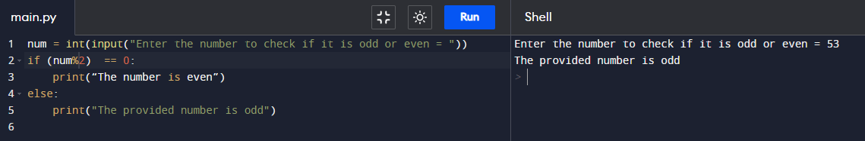

Q18. What are boolean operator?

Ans: Operators are special symbols in Python that is used to perform arithmetic or logical computations. The values on which operation is to be done are called operands. while the operation is denoted by operator.

e.g. (+, -, /, *, %, etc.)

Q19. What will the output of the following?

1 or 0 = True

0 and 0 = True

True and False and True = False

1 or 0 or 0 = True

```

Q20. What are conditional statements in Python?

**Ans:** Python supports the usual logical conditions from mathematics:

* Equals: a == b
* Not Equals: a != b
* Less than: a < b
* Less than or equal to: a <= b
* Greater than: a > b
* Greater than or equal to: a >= b

These conditions can be used in several ways, most commonly in "if statements" and loops. An "if statement" is written by using the if keyword.

Q21. What is use of 'if', 'elif' and 'else' keywords?

Ans: If-elif-else keywords are used in Python for decision-making i.e the program will evaluate test expression and will execute the remaining statements only if the given test expression turns out to be true. This allows validation for multiple expressions.

Q22. Write a code to take the age of person as an input and if age >= 18 display "I can vote". If age is < 18 display "I can't vote".

**Ans:**

Age = int(Input(“Enter age = ”))

if Age >= 18:

Print(“I can Vote”)

else:

print(“I can’t vote”)

Q23. Write a code that displays the sum of all the even numbers from the given list.

```

numbers = [12, 75, 150, 180, 145, 525, 50]

```

**Ans:**

numlist = [12, 75, 150, 180, 145, 525, 50]

sum = 0

for num in range(7):

if numlist[num]%2 == 0:

sum = sum + numlist[num]

print ("Sum of even number = ", sum)

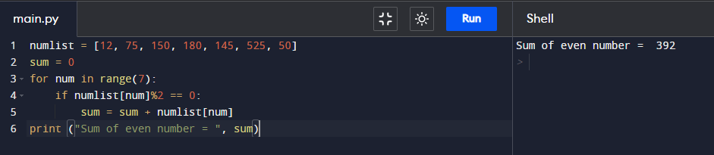

Q24. Write a code to take 3 numbers as an input from the user and display the greatest no as output.

**Answer:**

num1 = float(input("Enter first number: "))

num2 = float(input("Enter second number: "))

num3 = float(input("Enter third number: "))

if (num1 >= num2) and (num1 >= num3):

greatest = num1

elif (num2 >= num1) and (num2 >= num3):

greatest = num2

else:

greatest = num3

print("The greatest number is", greatest)

